* **Title** – Adventure Quest
* **Description/feature set** – Gameplay- take control of the adventurer and fight enemies and then face the evil wizard. Story- The adventurer a hero tasked with clearing the forest from evil skeletons and goblins. They have taken over the forest and where summoned by the evil sorcerer.
* **Purpose/application** – The game’s purpose is to entertain and put you in the shoes of the adventurer. As him you fight evil monster and defeat the evil sorcerer
* **Premise/high concept** –You the player are part of an elite adventure guild. Members have been sent to clear an evil forest from skeletons and goblins. None have returned, now you must go forth and clear the forest from evil. Take control of the fearless adventurer and slice your way through monsters and face the evil sorcerer, this battle won’t be easy but only you can save the kingdom, because if you fail all hope is lost.
* **Genre** – RPG
* **Platform** – unity, pc
* **Audience/market** – This game is for people who like RPG’s and fighting games. The age bracket is for kids 9 and up, and retro gamers.
* **Rating** – E for everyone because the game is pixel and there is no blood
* **Player mode** –single player
* **Time interval** – real-time
* **Backstory/synopsis** – The evil forest has always been known to have evil energy, but an evil sorcerer has tapped into that energy and now he has summoned an army to take over the kingdom.
* **Character descriptions** – Adventurer: wears silver armor with a red scarf wrapped around and has leather boots, also wields a longsword. Evil sorcerer: wears a long purple robe, has a hood that covers his face, and wields a long crystal staff with purple smoke coming out of it. Skeleton: Tall and wears armor, also wields a sword.
* **Competitive analysis** –
* The adventure of link: Take control of link as you travel through hyrule fighting monsters and solving puzzles in dungeons, to save princess Zelda from her slumber. This game is similar because it is a side scroller where you control link to move jump and attack. The adventure in Adventure Quest also can do the same things. The reason why you should play my game is because the graphics are more up to date 64-bit vs the adventure of links 16 bit, also my game is way less complicated then adventure of link.
* Golden axe: Choose between three hero’s male knight, female warrior, and dwarf barbarian. Each character has different attacks and special moves. Control one of the heroes to defeat evil most enemies will take two hits to defeat others will take more. By defeating enemies, you collect power that power when filled you can use a special attack which can destroy multiple enemies. This is like mine because both have hit boxes and health for hero’s and enemies. The reason you should play mine over is because, golden axe feels like a neverendingly game, while mine is short and simple.
* Contra: Take control of one of the gunner bros and shoot your way through hordes of enemies and try to save a crumbling city. A long the way drones will give you special abilities like rapid fire, shield, and rocket bullets. Also, you can collect bombs, when you use one it will decimate everything in front of you. This game is like mine because both are side scrollers. The reason you should play mine is because, mine the game is easy while Contra the levels are long, and the enemies can deplete your lives and boom you must start all over.

* **Rules** –Single player, E for everyone, about 10 minutes long, victory condition defeat every enemy and beat the final boss, lose condition if your adventure health reaches 0 game over.
* **Challenges** – Skeletons, Goblins, and the final boss the evil sorcerer
* **Strategies** – Discuss 3 strategies that players must use during the game to overcome the game’s challenges. First the player must know when to fight and when to doge, second watch your lives especially when fighting the final boss, lastly patterns every enemy has a pattern learn it to defeat them.
* **Theory/game balance** – What type of game theory elements are you using in the game? Skill vs luck(randomness) every enemy has a specific pattern, for example a skeleton will attack then jump backwards and repeat. Players can easily lose all their lives by enemy’s but when the player dies, they learn the patterns and time when to attack and when to avoid.
* **Perspective/game view** – Side scroller, the environment is a forest with large trees in the background, as the player moves it seems like they are moving through the forest, but the background just repeats.
* **User interface** – single player. The player uses the arrow keys on their computer to control the adventurer, right arrow to move forwards, left arrow to move backwards, up arrow to jump, and spacebar to attack. Also, you can press on the up arrow and then press spacebar to perform a jump attack.
* **Audio** –music: Forest theme(repeats), sound effects: Enemy take damage, player take damage, and death.
* **Summary/future updates** –Adventure Quest single player, RPG, player controls the adventure and fights their way through the evil forest and faces skeletons and goblins. Finally making their way to face the evil sorcerer. Updates: Note this was my other idea but because of time I decided not to do it so, if I had time Adventure Quest would become Neo Legends.

Title – Neo Legends

• Description/feature set – Enter the world of Technorule where you play as a legendary hero. The land has been taken over by evil only the legendary hero can destroy the darkness.

* Gameplay control the legendary hero and fight your way through Technorule to get to the castle where the king of darkness awaits.
* Story, Technorule was in a time of peace until the king of darkness broke free from his prison, and kidnapped Princess Sophie. Now he has spread evil across the land. You awake and hear a voice calling to you. You follow it and find yourself facing the evils bane, a sword that the legendary hero once held. You pull the sword and discover you are the descendent of the hero. Now with the evils bane you must save Technorule.
* Characters, the legendary hero( the player can name him), the king of darkness, Princess Sophie
* Enemies, Techno Bloblins( Bloblins with futuristic gear), and Nano Slimes
* Visuals, 64 bit, 2d, and side view.

• Purpose/application – What is the game’s purpose, the purpose is to show players that they are the hero. To put the players in the hero’s shoes.

• Premise/high concept – You the player, take control of your destiny and discover you are the descendent of the legendary hero. Now with the evil’s bane a sword, with a blade made of plasma. Fight hordes of the dark kings’ minions. Princess Sophie has been captured by the dark king; you must save her for she holds the key to defeating the dark king. Fight your way through Technorule, to get to the castle a magnificent palace with neo lights covering the exterior, to defeat the dark king and claim your destiny. Welcome to Neo Legends

• Genre – Action, RPG

• Platform – Unity, pc

• Audience/market – 10-year old’s, boys, and girls who enjoy role playing games. I think they will enjoy playing as the hero and fighting baddies through a cyberpunk land.

• E 10+ the reason is for violence, and mild blood.

• Player mode – single player

• Time interval –real-time

• Backstory/synopsis – What happens before the game’s action begins? Words on the screen say awake oh hero. Then it shows the hero, a prompt says, “ Press Left arrow to move backwards, press Right arrow to move forwards.” The player can move the hero outside. Words on the screen say, “Come hither time to awaken me.” The player moves the hero to the direction the words came from. The player comes across a courtyard with a sword in a pedestal. The player walks to the pedestal and a prompt says press “P” This will make the player now acquire the evils bane. Another prompt shows up and says. “Oh, hero beware evil is near press P to slay them.”

• Character descriptions – The hero, human blond short hair, pale skinned, and has blue eyes. He wears a green leather jacket, and baggy sweatpants held up by a belt, he also wears brown fingerless gloves.

Princess Sophie, human brown long hair, dark skinned, and has green eyes. Has a golden tiara, wears a purple dress, with silver armor underneath.

King of darkness, a skeleton who wears silver armor with skulls on the leg plates.

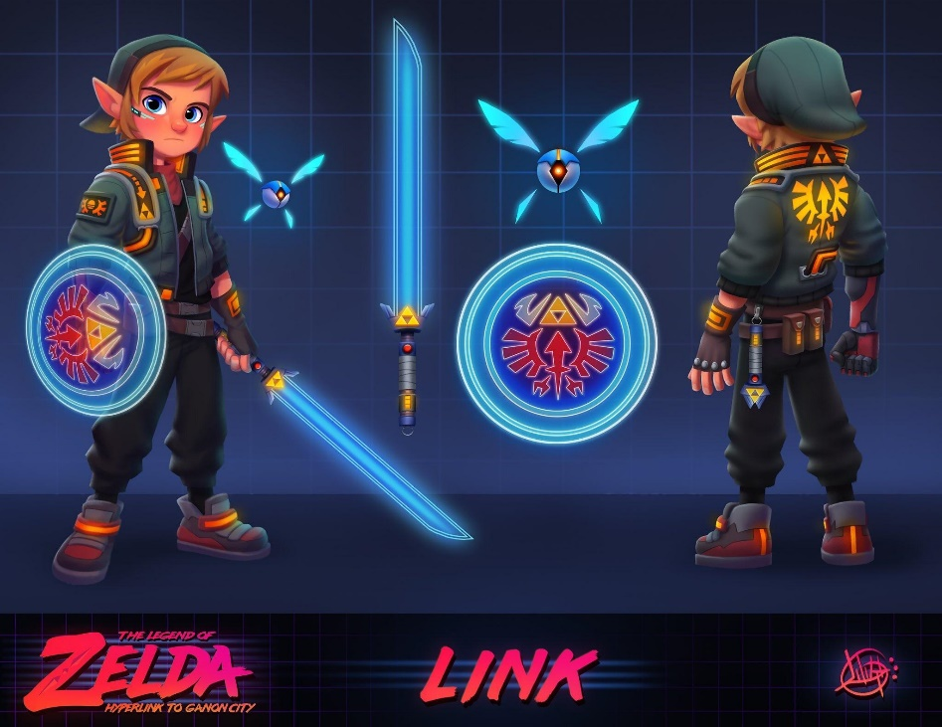

• Competitive analysis – the legend of Zelda, play as link and explore Hyrule to collect the pieces of the triforce to save Zelda and defeat Gannon.

• Rules – Player has three lives, when enemy hits player, player loses a life. If player hits enemy depending on enemy type will either lose one life or die. (Note, Nano slimes have one life, Techno Bloblins have two.) If player loses all lives player dies and gamer must restart. If enemy loses all lives enemy is dead. King of darkness has four lives, but he can do two damage to the player. Also falling rocks do one damage to player.

• Challenges – Nano slimes, Techno Bloblins, falling debris, boss king of darkness.

• Strategies – Patterns: Each enemy has a pattern Bloblins will move forwards and then attack, Slimes will keep jumping towards the player till they can attack, and king of darkness will attack, move backwards, and then jump and attack. Timing: Players will need to know when to attack or avoid.

• Theory/game balance –skill vs luck (randomness), The enemies have set attack animations, but they can seem random because they have ai, Players skill will help determine when to attack and when to avoid, also skill will help you keep you lives to fight the final boss. But the game will not punish nonskilled players enemy’s drop hearts which will restore your life.

• Perspective/game view –The game view be side-scrolling, 3rd person, the environment is Technorule field, Castle town, and castle. Field: a grassy wasteland with rubble littering the field, Castle town: A cyberpunk city with neon lights shining through the city, Castle: Red carpet with golden trim across the walls, boss room: Red carpet surrounded by black darkness.